|  |
| --- |
| **PENETRATION TEST REPORT** |
| **Information Gathering and Vulnerability Assessment**  **Report** |
| Penetration Tester – Nagunoori Prabhath Chandra  Phone Number – 6300764712 Email: [chandraprabhath5@gmail.com](mailto:chandraprabhath5@gmail.com) |

## Document Control

|  |  |  |
| --- | --- | --- |
| **Document Version** | **Owner & Role** | **Status & comments** |
| v1.0 | Nagunoori Prabhath Chandra – Penetration  Tester | Prepared the Internal Draft |

## Disclaimer

The content of this report is highly confidential and may include critical information on Information Gathering and Vulnerability Assessment. The report should be shared only with intended parties.

Although maximum effort has been applied to make this report accurate, Nagunoori Prabhath Chandra cannot be held responsible for inaccuracies or systems changes after the report has been issued since new vulnerabilities may be found once the tests are completed.

Moreover, Nagunoori Prabhath Chandra cannot be held responsible on how the report is implemented and changes made to DVWA Vulnerabilities . systems based on the recommendations of this report. Guidance should be taken from a network and security expert on how best to implement the recommendations.

All other information and the formats, methods, and reporting approaches is the intellectual property of Nagunoori Prabhath Chandra and is considered proprietary information and is provided in confidence to DVWA vulnerabilities and Information gathering for the purpose of internal use only.

Any copying, distribution, or use of any of the information set forth herein or in any attachments hereto form outside of DVWA Org.‘s authorized representatives is strictly prohibited unless DVWA organization obtains prior written consent of Nagunoori Prabhath Chandra.

Table of Contents

**Synopsis2**

Severity Scale3

Final Report4

**Enumeration5**

DVWA Vulnerability Scanning13

Conclusion7

## Executive Summary

# SYNOPSIS

This report summarises the penetration test that was conducted by **Nagunoori Prabhath Chandra** as an assignment for the Cyber Security Bootcamp **Institute of aeronautical engineering , Hyderabad ,India .** This report is an attempt at showcasing my skillset and methodology of conducting a Web Application Penetration Test. The goal of this "pentest" was to act as a threat-actor by performing cyber-attacks and different vulnerabilities, an open-to-all web application. This will serve to discover any present vulnerabilities that could result in a breach and be leveraged to access sensitive data by a real-world attacker. All issues discovered by the pentester( **Nagunoori Prabhath Chandra )** are achieved and verified through network evaluation, system vulnerability scanning and assessment, and both automated and manual exploitation (where applicable) of found vulnerabilities.

# FINDINGS OVERVIEW

While conducting the external penetration test, there were several critical vulnerabilities discovered in the Information gathering .I was able to scan the Nmap vulnerabilities , DVWA vulnerabilities, and exploit XSS vulnerabilities. This could lead to grave information leaks and insecure sessions for users.

# SEVERITY SCALE

**CRITICAL Severity Issue:** Poses an immediate danger to systems, network, and/or data security and should be addressed as soon as possible. Exploitation requires little to no special knowledge of the target. Exploitation doesn’t require highly advanced skills, training, or tools.

**HIGH Severity Issue:** Poses a significant danger to systems, network, and/or data security. Exploitation commonly requires some advanced knowledge, training, skill, and/or tools. Issue(s) should be addressed promptly

**MEDIUM Severity Issue:** Vulnerabilities should be addressed in a timely manner. Exploitation is usually more difficult to achieve and requires special knowledge or access. Exploitation may also require social engineering as well as special conditions

**LOW Severity Issue:** The danger of exploitation is unlikely as vulnerabilities offer little to no opportunity to compromise the system, network, and/or data security. Can be handled as time permits.

**INFORMATIONAL Issue:** Meant to increase the client’s

knowledge. Likely no actual threat

##### Penetration Test Report

**Final Report**

## Methodology

I utilized a widely adopted approach to performing penetration testing during the tests to test how well the target environment is secured. Below, a breakdown of the applied methodology is provided.

Information Gathering

Vulnerability Analysis

Exploitation

Post Exploitation

House Cleaning

* Information Gathering – Reconnaissance [Footprinting, Scanning and Enumeration]
* Vulnerability Analysis – Researching Potential Vulnerabilities and Analyzing them
* Exploitation – Using Exploits in order to validate the vulnerabilities of the target
* Post Exploitation – Everything that should be performed after successful exploitation
* House Cleaning – Ensuring that the Remnants of the Penetration Test are removed

## Tools Utilized

Tools used by me were Industry Grade in a combination of Open Source and Commercial Licenses.

1. Nmap – Industry’s Most Commonly used Open-Source Scanning Tool
2. Angry IP Scanner – An alternative of nmap.
3. MegaPing – MegaPing is an ultimate toolkit that provides complete essential utilities for IT administrators and solution providers. MegaPing can scan your entire network and provide information such as open shared resources, open ports, services/drivers active on the computer, key registry entries, users and groups, trusted domains, printers, and more.
4. Metasploit Framework – Industry Grade Most Popular Pen-Testing Framework Toolset
5. BurpSuite Professional – Best in Class Suite of Tools for Web Application Assessment
6. Linux terminal – Best tool to find the information about a **l** the tools

# ENUMERATION

### STEP 1: INFORMATION GATHERING

* Performed a map service version enumeration. Using the command

“nmap -sV 10.0.2.4” and have found out the smtp port 25 was active.

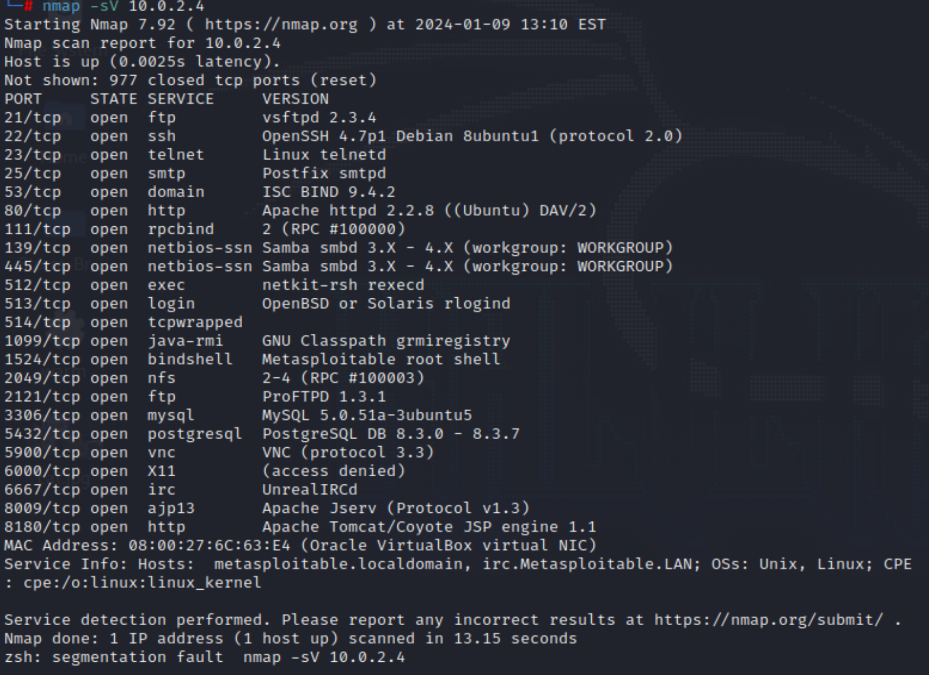



I’ve also used Angry IP Scanner to scan the IP range of the target. I have set IP range from 10.0.2.0 to 10.0.2.10. The following are the results about the scan. There are 4 hosts up. Here 10.0.2.4 is the only working one and has the host name METASPLOITABLE and the total number of ports open are 80.

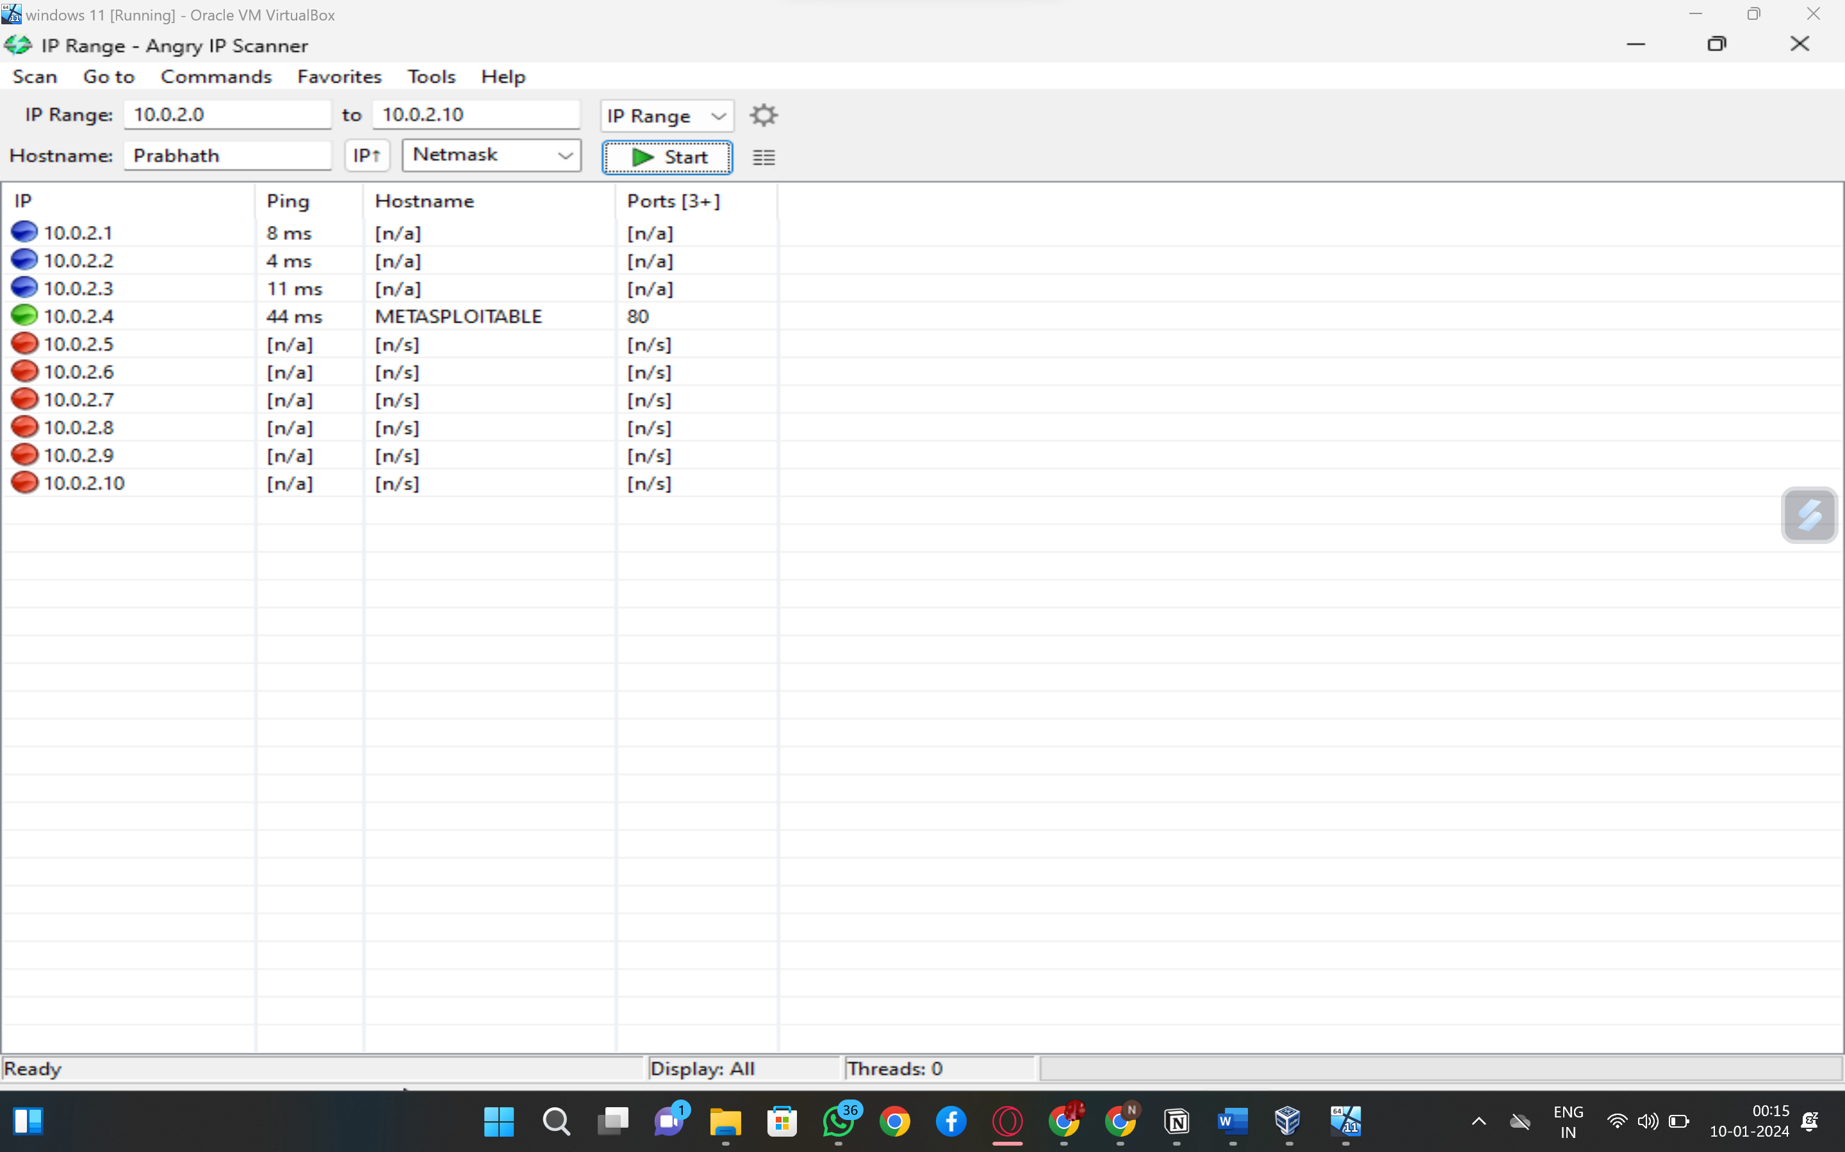

And I’ve also used MegaPing to know the host. Here I got the same results as the 4 hosts are up. The following picture shows the usage of MegaPing.

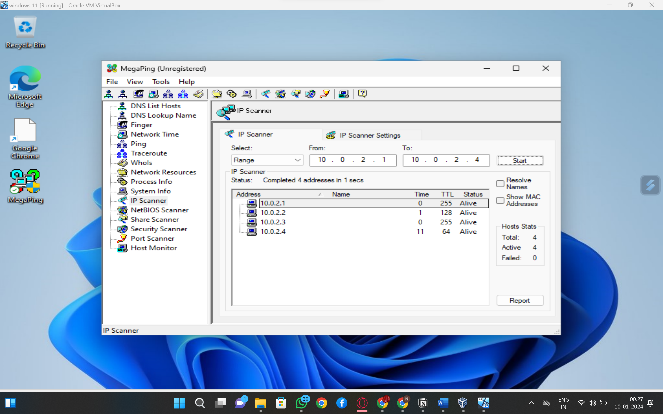

Then I have added all the IP addresses to the port scanner and checked all the IP addresses and got the information of the ports.

All the open ports are listed in the picture below. Open ports with high risk are displayed as **Elevated** in the **risk** section. Open ports with low risk are displayed as Low **risk** in the **risk** section.

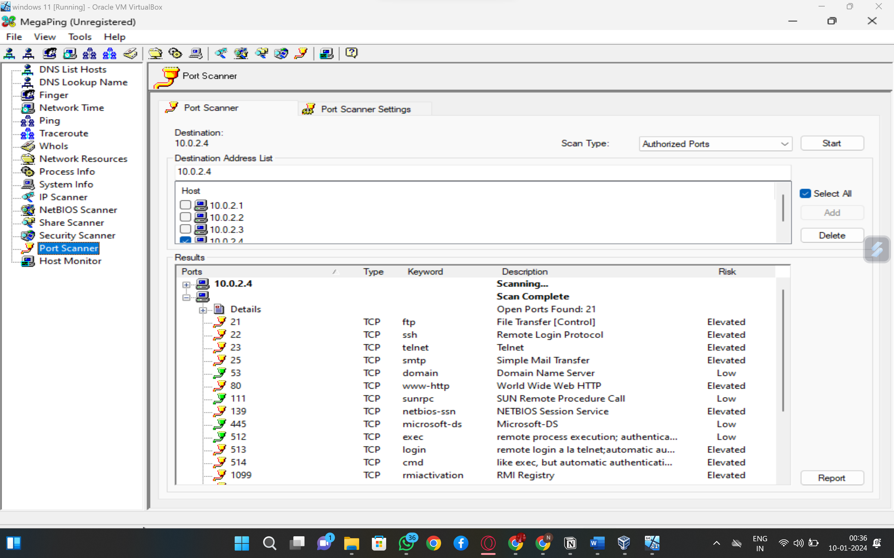

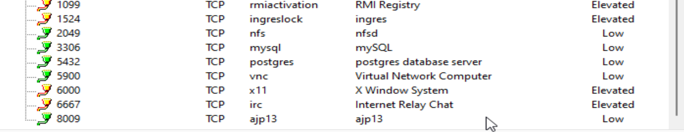

## Step-2: OS DETECTION ON Nmap

Found out the OS detection using the command “nmap -O 10.0.2.4”

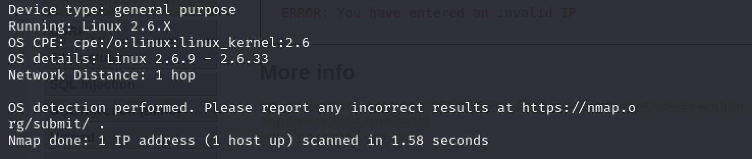

### Step-3: SCANNING OF FTP

Done port scanning of FTP and found a vulnerability in port no 21

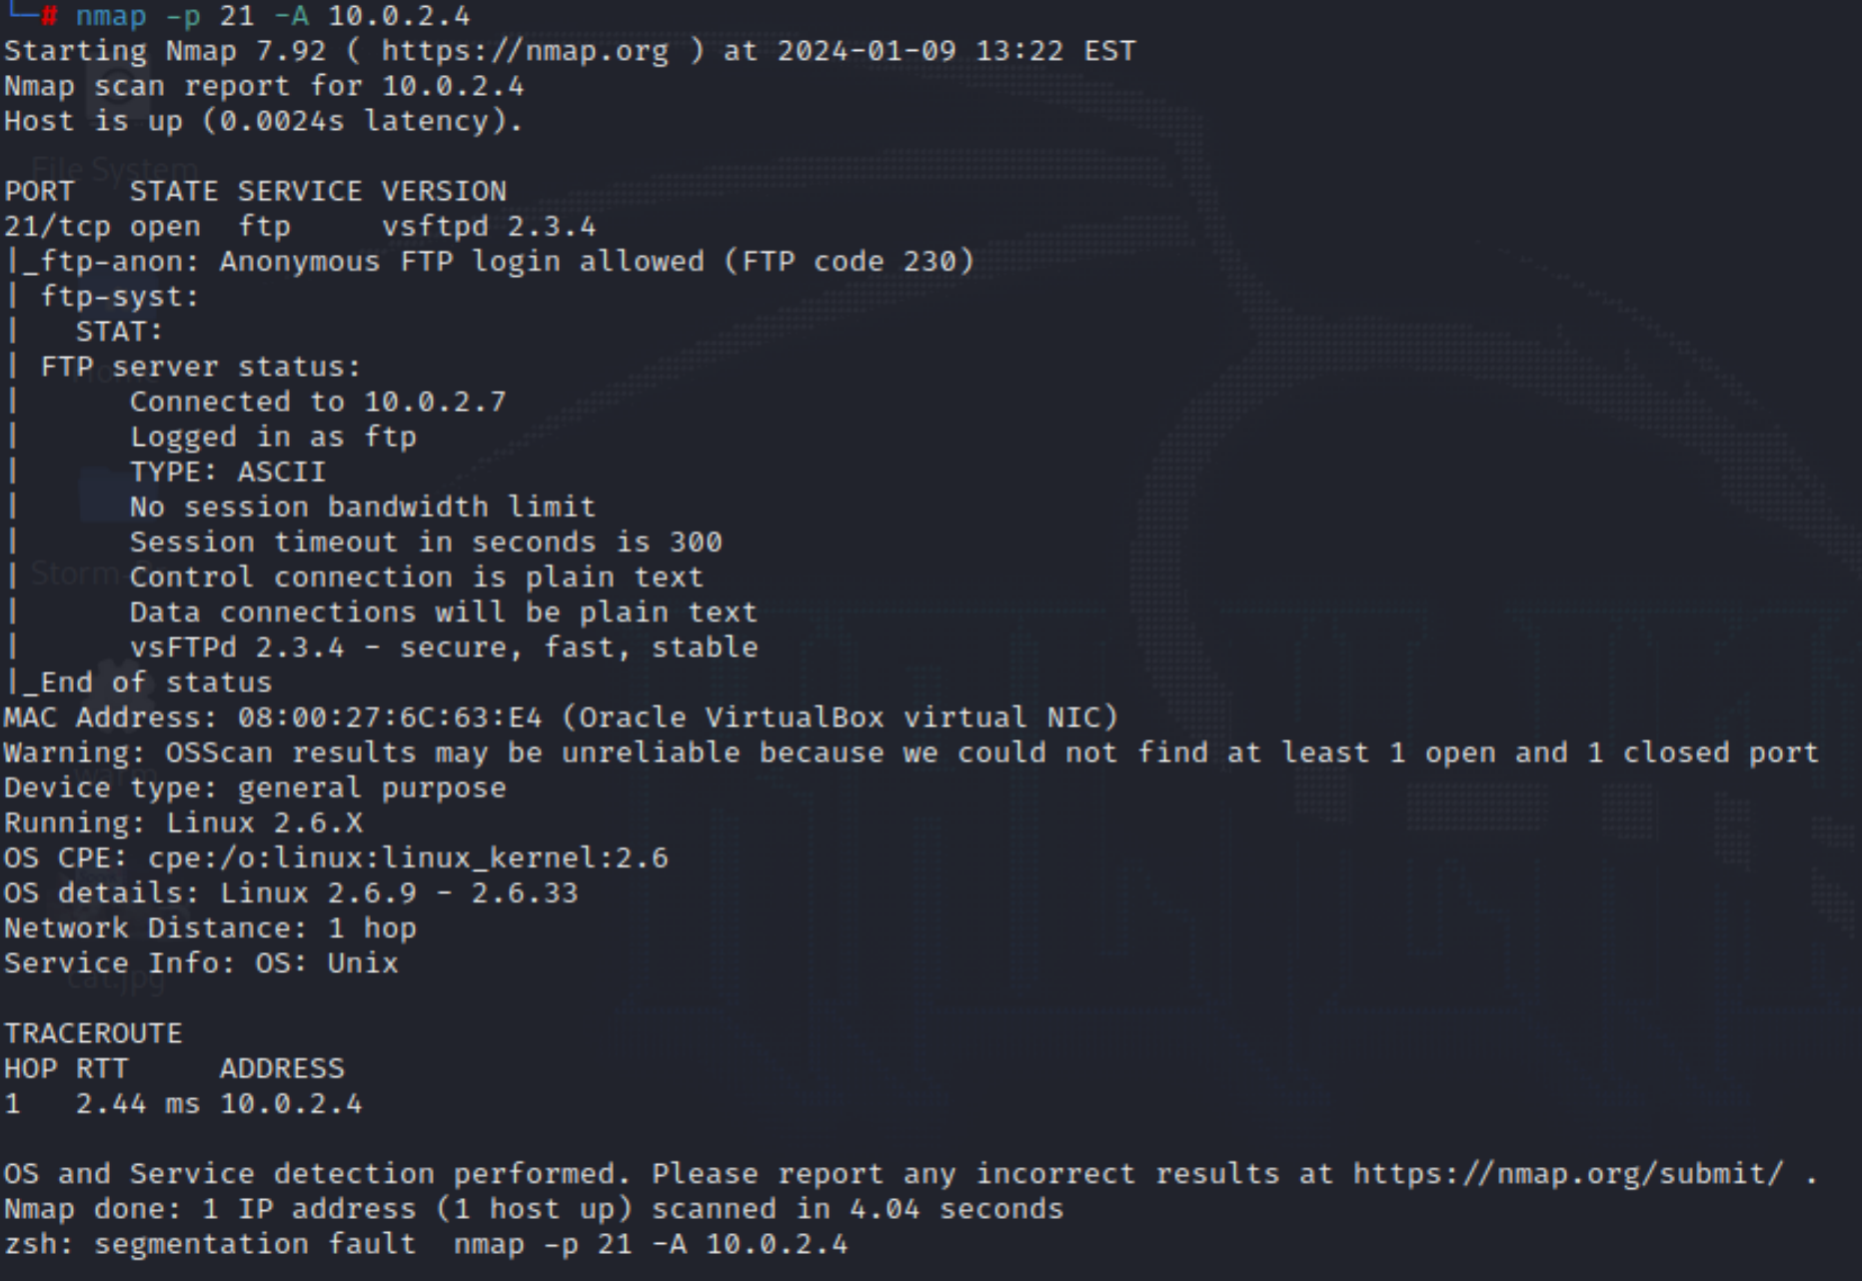

## Step-4: EXPLOITING VULNERABILITY

Exploiting Vulnerability in port no 21 by using “msfconsole”.

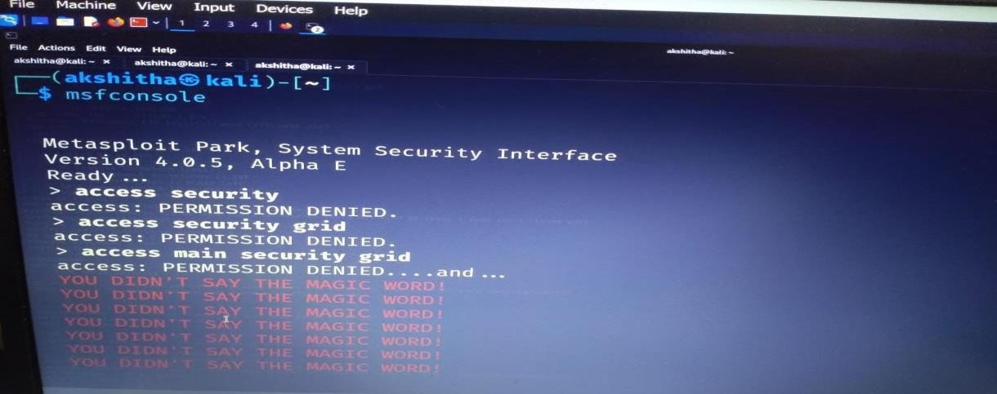

### Step-5: SEARCHING VSFTPD VERSION

When conducting information gathering in cybersecurity, it can be beneficial to determine the version of VSFTPD (Very Secure FTP Daemon) running on a target system, as this information can help in identifying potential vulnerabilities or exploits associated with specific versions.

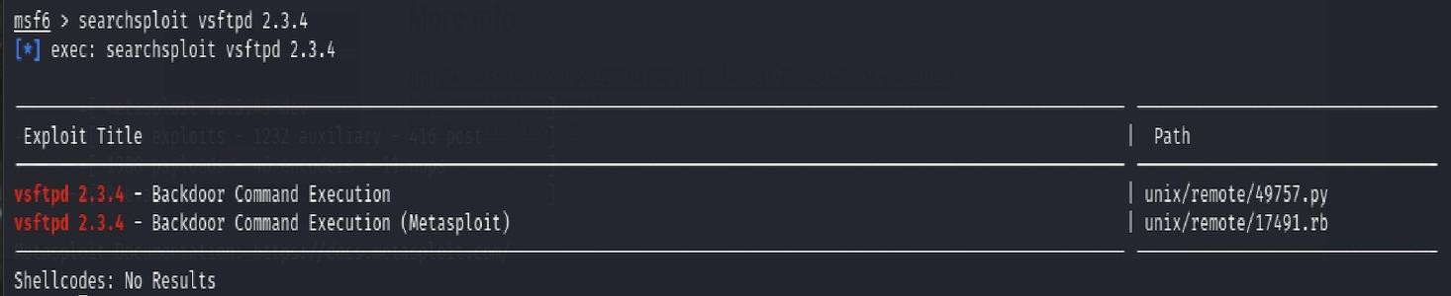

* After msf console it shows the global options , those options are called as

options or modules . After running "msfconsole," you will be presented with a console interface for the Metasploit Framework. This framework is widely used for penetration testing, vulnerability assessment, and exploitation.

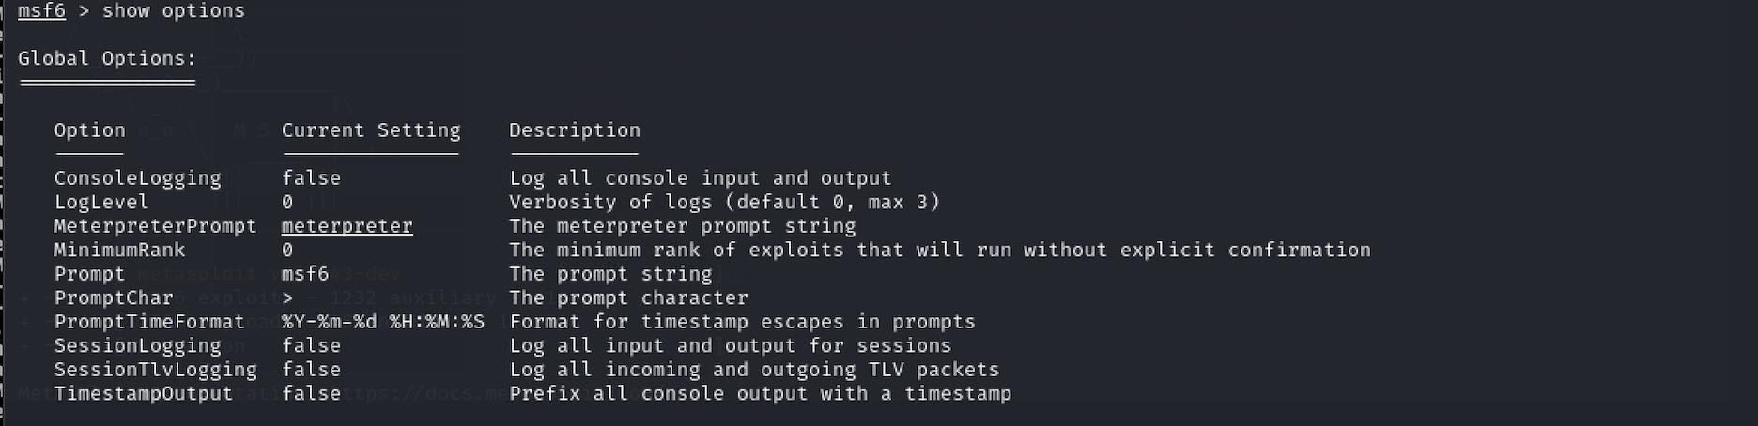

* When you set the RHOSTS parameter, you are essentially specifying the IP address of the remote system that you are attempting to exploit or interact with using Metasploit. This command sets the RHOSTS parameter to the specified IP address, enabling subsequent modules or exploits to target the specific remote host.

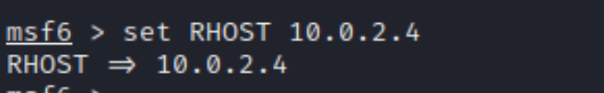

* Exploiting the vulnerability present in the port-21

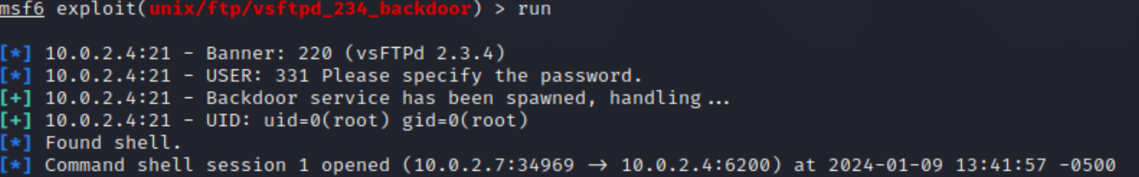

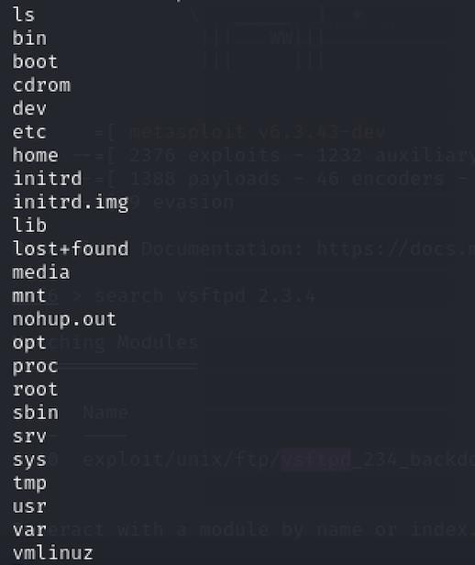

**DVWA Vulnerability Scanning**

1. **COMMAND INJECTION :**
   * DVWA (Damn Vulnerable Web Application) is intentionally designed to be vulnerable for educational purposes, allowing users to practice and enhance their penetration testing skills in a legal and controlled environment.
   * **Command Injection** is one of the common vulnerabilities that can be found in web applications, and DVWA provides a platform to practice exploiting such vulnerabilities.
   * In DVWA, the Command Injection vulnerability allows an attacker to execute arbitrary commands on the underlying system by manipulating input parameters.

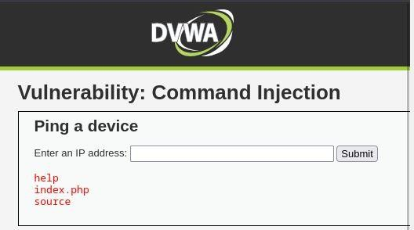

**DVWA Vulnerability Scanning**

1. **Cross Site Request Forgery (CSRF):**

Cross-Site Request Forgery (CSRF) is a web security vulnerability that allows an attacker to trick a user into performing actions they did not intend to perform. In the context of DVWA, CSRF vulnerabilities are intentionally included to allow users to practice identifying and exploiting such issues.

“”””http://127.0.0.1:42001/vulnerabilities/csrf/?password_new=12

3456&password_conf=123456&Change=Change# “””

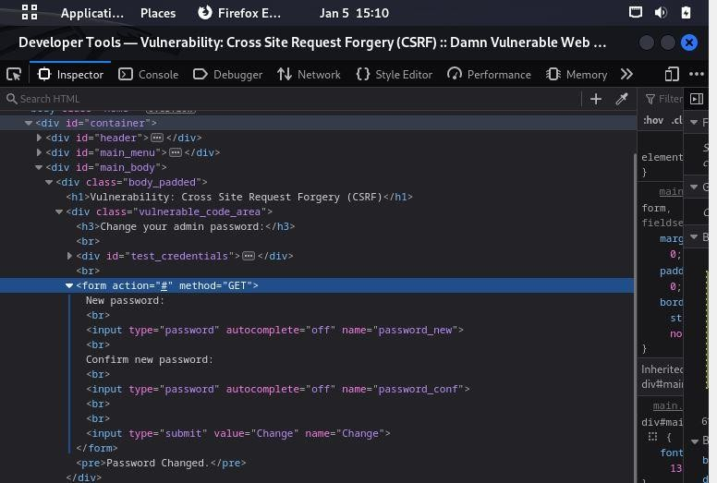* By sending this url to an authenticated email user he/she can will click on the link , they try to login . If the url gets worked then actual user will get the message as “ pasword changed”.

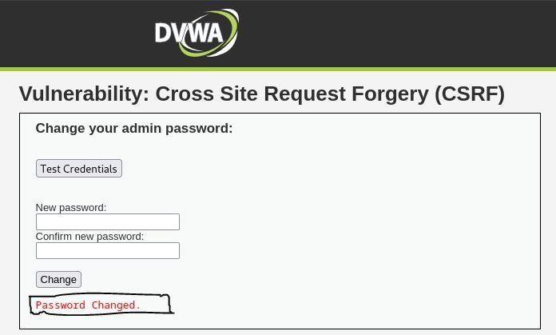

1. **Brute Force:**

I have scanned for some security vulnerabilities by Brute Force Attack.

**\***an attacker attempts to guess the correct username and password combination by trying all possible combinations until they find the correct one. This type of attack can be time-consuming and resource-intensive, but it can also be effective in certain situations.

*In the Burp Suite tool, I followed the path:Target→Site map→http://localhost →URL Containing the following:/DVWA/vulnerabilities/brute/?username=admin&password=admin&Login=Login HTTP/1.1

•Navigated toRequest→Rawtab →Right-click inside→Send to Repeater.

•I selected theIntrudertab →Positions. And we canChoose an attack type, AddorClearpayload markers, and Start attack.

* Both username=admin and password=admin are marked as payloads.

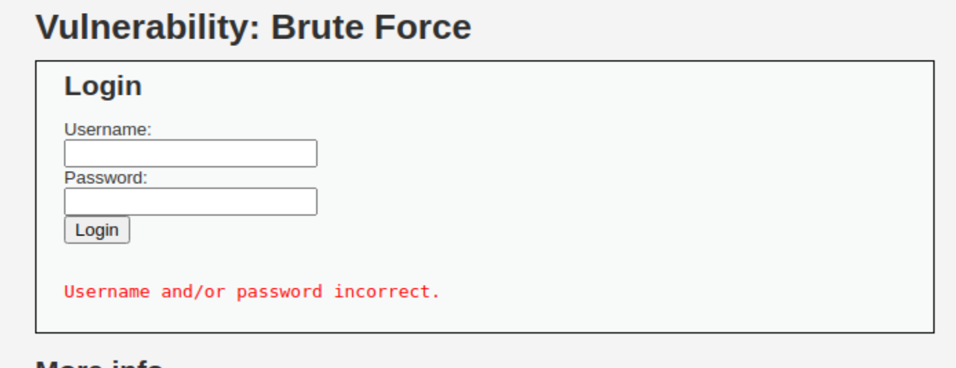

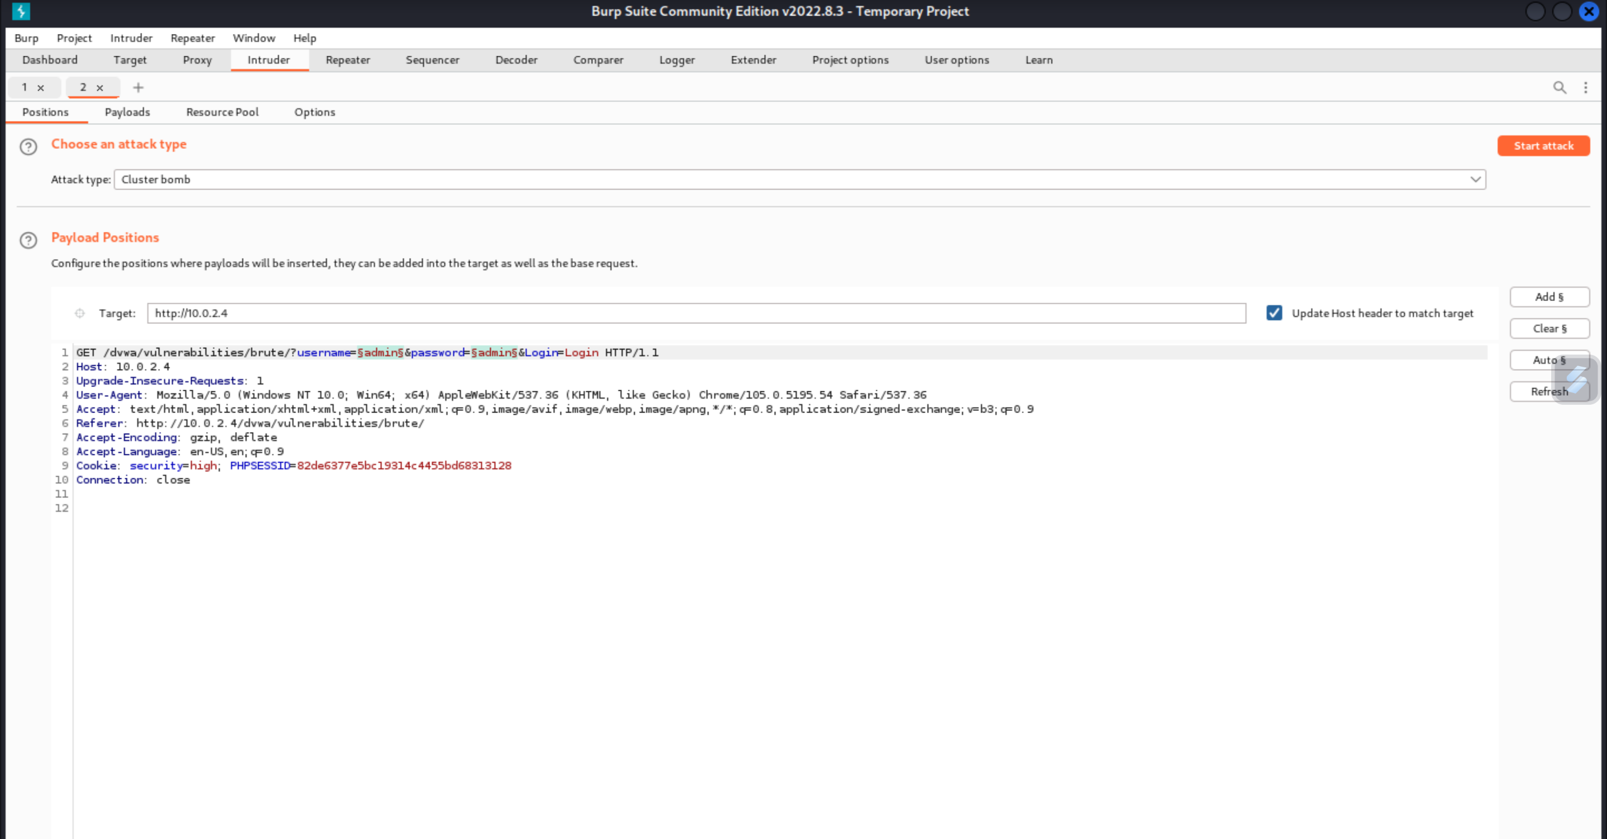

*I have attacked some Payloads:

Payload 1: username list

Payload 2: password list

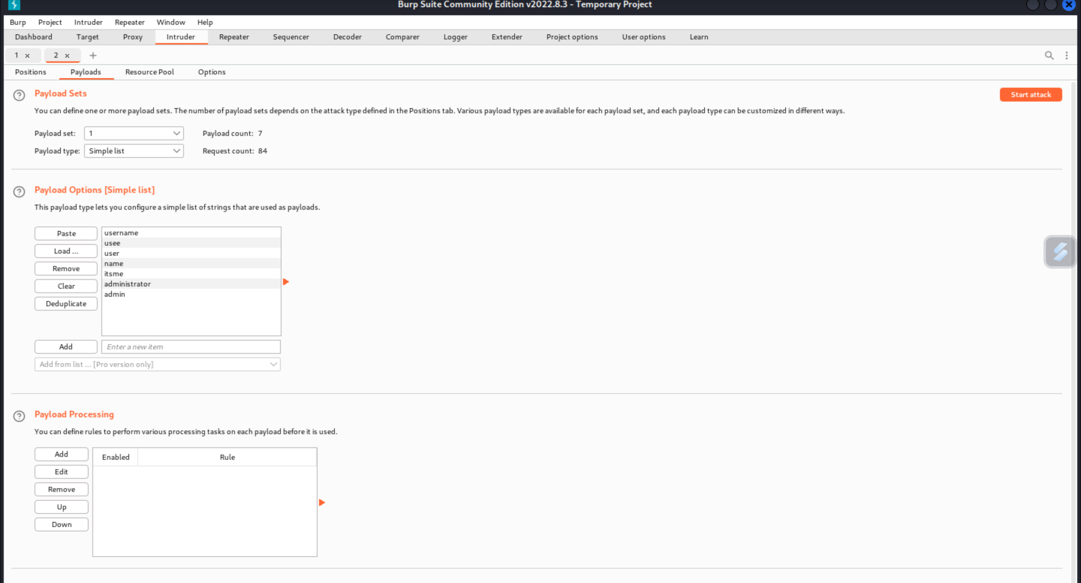

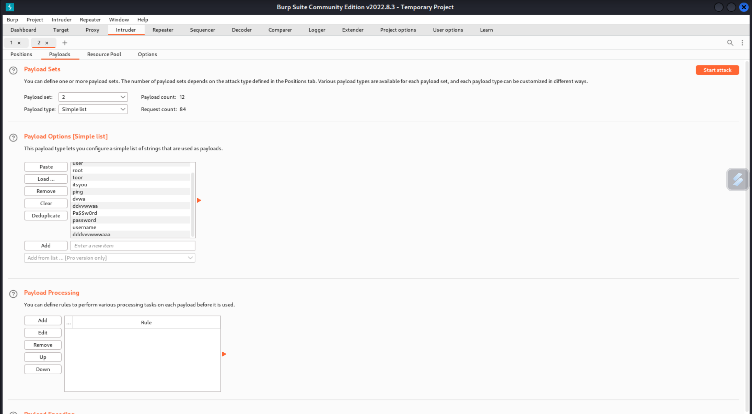

## Here I have set the Grep-Match value to (Username and/or password incorrect.) Which is used to compare the output when the password is correct or incorrect.

## 

## In the request 70 field, the user name is “admin” and password is “password” which can be found through the field mentioned after the length field where there is no “1” specified there.

## 

## SQL Injection:

## SQL injection is a type of cyber attack that involves injecting

## malicious SQL code into a database query through an application

## vulnerability.

## * Use this command for getting the Id 1' OR '1'='1'#

## 

## *Here I’m using 2 as the input in the user ID field

## 

## *And now I’m ‘ or 1=1 in the user id field and I got the below results.

## 

## *Here I’m using the input as (select 2) in the User ID field.

## 

## *For this vulnerability we are using unhex() to bypass. The following picture shows the Hexadecimal number required to enumerate this vulnerability in user database.

## 

## *In the following step I have entered unhex(27) or 1=1# in the User ID field and got the following results.

## 

## *The following picture shows the enumeration of the user database by using this following input unhex(27) or 1=0 union select table_name,2 from information_schema.tables#

## Which gives the following output of the user database.

## 

## *And by using the payload unhex(27) or 1=0 union select user_id,password from users# and the output we get is in the following picture.

## 

## In the above picture the firstname is the username and the value after surname is the password.

## EXPLOITATION

## In the Exploitation phase, I will attempt to exploit find vulnerabilities within the scope. The end goal for the tester is to attempt to penetrate into the target environment, gaining as much privileges as possible, and avoiding detection while doing so. I will stay with in the scope that was determined during pre-engagement activities and documentation.

## VULNERABILITY EXPLOITED:

## Command Execution

## 

## SEVERITY:

## MEDIUM

## Vulnerability Explanation: Command Execution in DVWA is a command injection vulnerability that can occur when user input, which should not be interpreted as commands, is executed as if they were for the server. This exploit allows a user to inject malicious SQL code into the command line based on the input they provide, allowing them to manipulate and extract sensitive data. Addressing this vulnerability involves disabling command line execution, using parameterized SQL queries to protect against malicious injection, and validating user input to prevent any potential security risks.

## Reference:

## https://www.owasp.org/index.php/Testing_for_Command_Injection_(OTG-INPVAL-013)

## Command Injection:

## I was able to successfully find out the

## vulnerability by using the following command Passing.

## 

## the query “ 10.0.2.15 | ls ” I find out the vulnerability.

## present by using the Command injection.

## VULNERABILITY EXPLOITED:

## XSS (Reflected)

## SEVERITY:

## CRITICAL

## Vulnerability

## Explanation: Cross site Scripting ( is an attack technique that involves echoing attacker supplied code into a user's browser instance. A browser instance can be a standard web browser client or a browser object embedded in a software product such as the browser within WinAmp, an RSS reader, or an email client. The code itself is usually written in HTML/JavaScript, but may also extend to VBScript, ActiveX, Java, Flash, or any other browser supported technology.

## Vulnerability Mitigation: Use a vetted library or framework that does not allow this weakness to occur or provides constructs that make this weakness easier to avoid Examples of libraries and frameworks that make it easier to generate properly encoded output include Microsoft's Anti XSS library, the OWASP ESAPI Encoding module, and Apache Wicket.

## Reference:

## http ://projects.webappsec.org/Cross Site Scripting

## http ://cwe.mitre.org/data/definitions/79.html

## Reflected XSS: I've tried inserting the string <script> alert(‘a’) </script>

## into the text fields in the web app. The search box showed

## that it could process the string.

## 

## The following proves that the web application is processing XSS requests without any sanitization.

## 

## Creating an alert with the session cookie with the string <script> alert(document.cookie) cookie)</ reveals that the login credentials are being revealed. This makes it extremely easy for a hacker to steal login credentials through persistent XSS.

## 

## Finding It was found that the search field was forwarding and processing XSS requests without any sanitization. It was also found that the session cookie reveals the login credentials of the logged in user.

## Conclusion

Example Organization suffered a series of control failures, which led to a complete compromise of many in-scope machines. These failures would have had a dramatic effect on the company’s operations if a malicious party had exploited them.

The overall risk identified to Example Organization as a result of the penetration test is High. A direct path from external attacker to full network compromise was discovered. The fact that all 5 systems in sco pe were compromised makes it clear that these systems were not tested from a long time and since, they are all placed at the DMZ area, It’s a risky situation.

The primary goal of this penetration test was stated as identifying if there is any weakness in Example Organization’s Network that could potentially be used by attackers to access sensitive health (PHI) or payment data which would violate **HIPPA or PCI-DSS** compliances.

These goals of the pentest were met and in-fact much more than this. Many critical vulnerabilities were found during the test that directly affect confidentiality, integrity and availability of the information and systems. Majority of the findings have occasional prevalence, easy exploitability, and devasting impact with simple prevention.

It was found that your security architecture has few patterns:

○ Operating Systems are Outdated and Unpatched.

○ Softwares and Services are Outdated.

○ Passwords are either defaults or very weak.

○ Security Controls are either not defined or implemented in most cases.

○ All the vulnerabilities found have easy mitigation

In conclusion, these vulnerabilities should not be there in the first place. Example Corporation needs to redefine their Information Security Management Program and rethink their processes.

## Recommendations

Due to the impact to the overall organization as uncovered by this penetration test, appropriate actions should be taken to remediate and safeguard your IT infrastructure.

Though mitigation for specific vulnerabilities has already been given in this report,

##### Additionally, we recommend the following:

1. Establishment of Updates & Patch Management Program
2. Implementation of WAF and IPS
3. Source Co de Review of Deployed Applications and Sanitization
4. Alignment of Security Policies with Industry’s Best Practices
5. Use a Custom 404 (Not Found Error) Page
6. Social Engineering training for every employee
7. Vulnerability Scanning on at least monthly basis (Scan – Patch – Scan Again)
8. Installa HIPS and DLP to stop common attacking payloads like meterpreter

## Additional Items

#### Appendix A - References:

There are some concepts and special tools Iused, to which Ihave given the links below -

* + **Kali Linux -** [https://www.kali.org/do wnloads/](https://www.kali.org/downloads/)
  + **Vsftpd Exploit -** [rapid7.com/db/modules/exploit/unix/ftp/vsftpd_234_backdoor/](https://rapid7.com/db/modules/exploit/unix/ftp/vsftpd_234_backdoor/)
  + **Rooting Guide -** [blog.g0tmi1k.com/2011/08/basic-linux-privilege-escalation/](https://blog.g0tmi1k.com/2011/08/basic-linux-privilege-escalation/)

#### Appendix B - Glossary:

There are some technical terms in the report which are important to be explained here -

* + **Black Box Penetration Test -** In penetration testing, black-box testing refers to a method where an ethical hacker has no knowledge of the system being attacked. The goal of a black-box penetration test is to simulate an external hacking. It is the most unreliable form of penetration testing.
  + **Social Engineering –** It is the art of using deception to co n someone into providing information or access they would not normally have provided. It’s the “human side” of breaking into a network and preys on the qualities of human nature, such as the desire to be helpful, the tendency to trust people and the fear of getting in trouble. According to recent statistics, 98%of all cyber-attacks rely on social engineering.